How to install MYSQL
Go to google
Type MYSQL
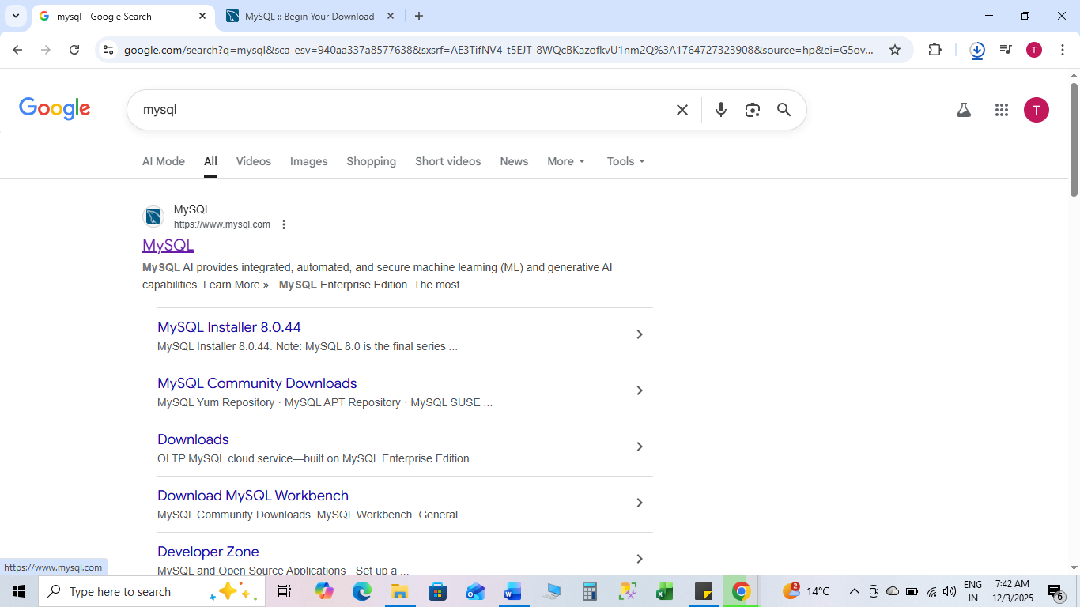

Click on DOWNLOADS
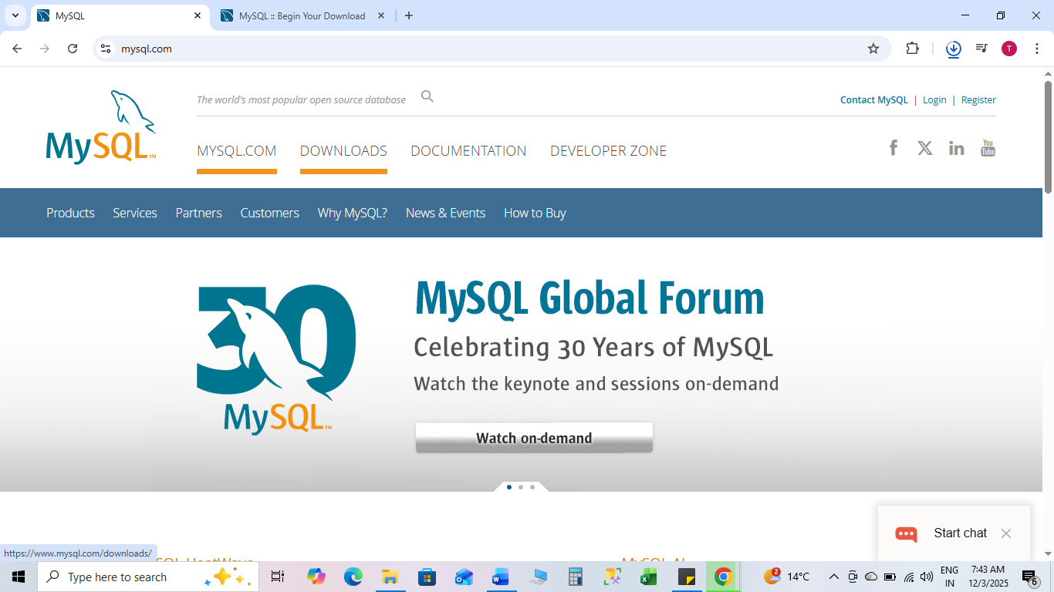

Come at the bottom of the website
click on MySQL Community (GPL) Downloads
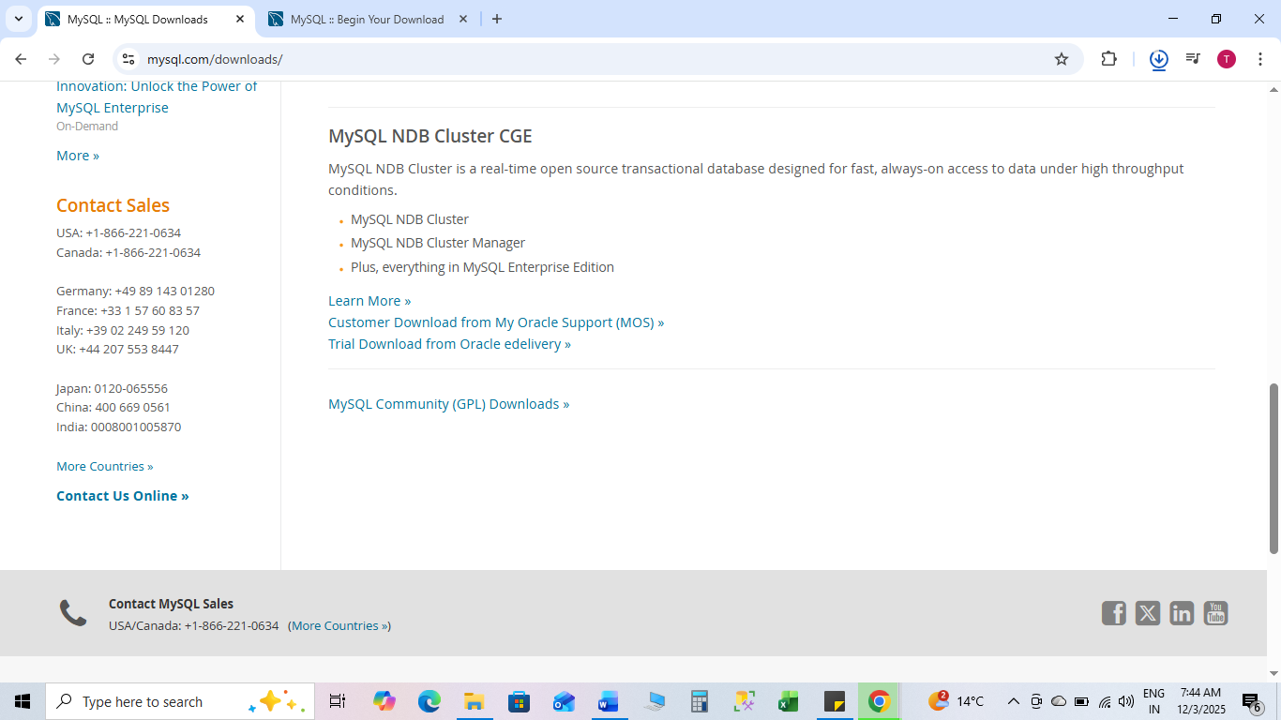

- click on MySQL Installer for Windows
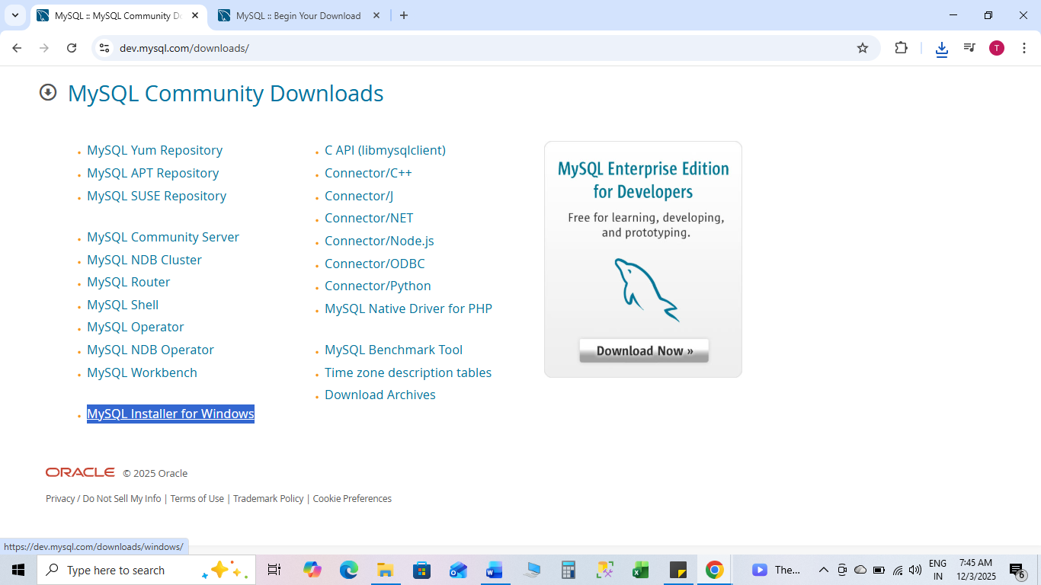

click on Download
Windows (x86, 32-bit), MSI Installer | 8.0.44 | 558.3M | Download
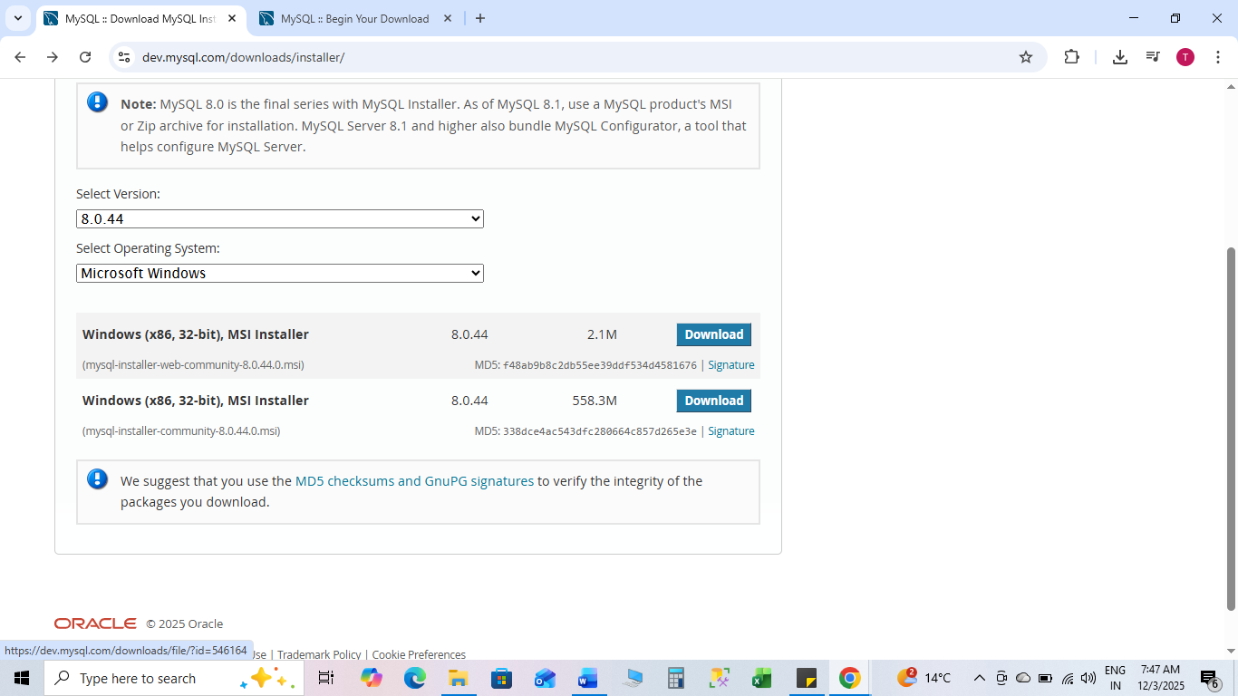

Click on No thanks, just start my download.
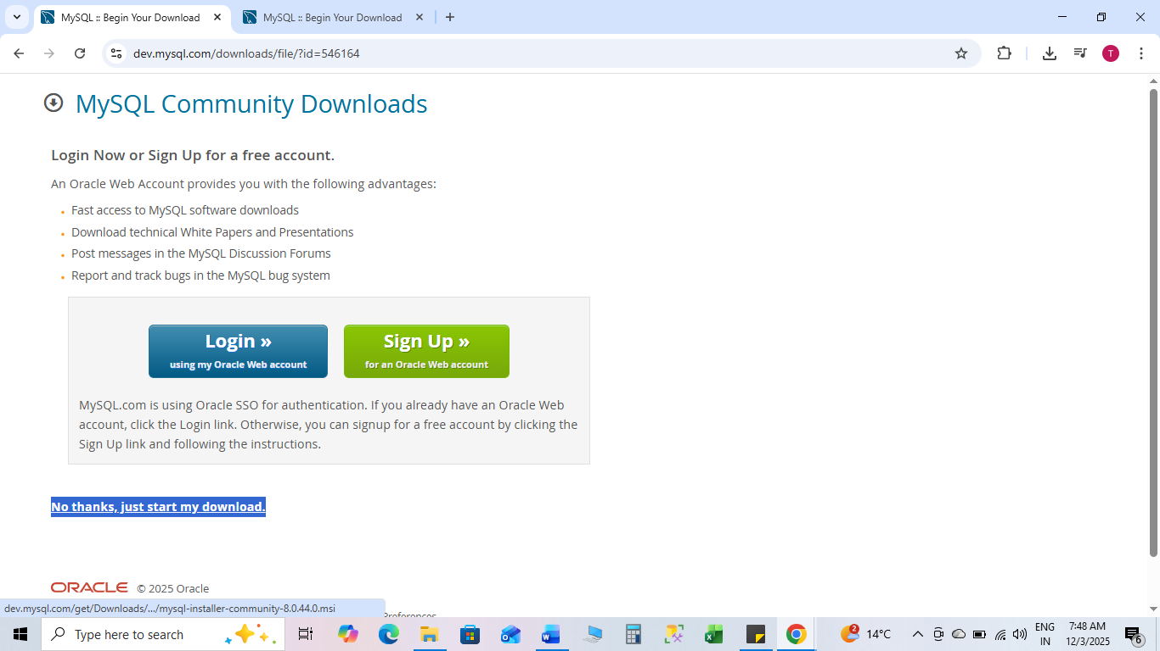

Download start and you will get setup file
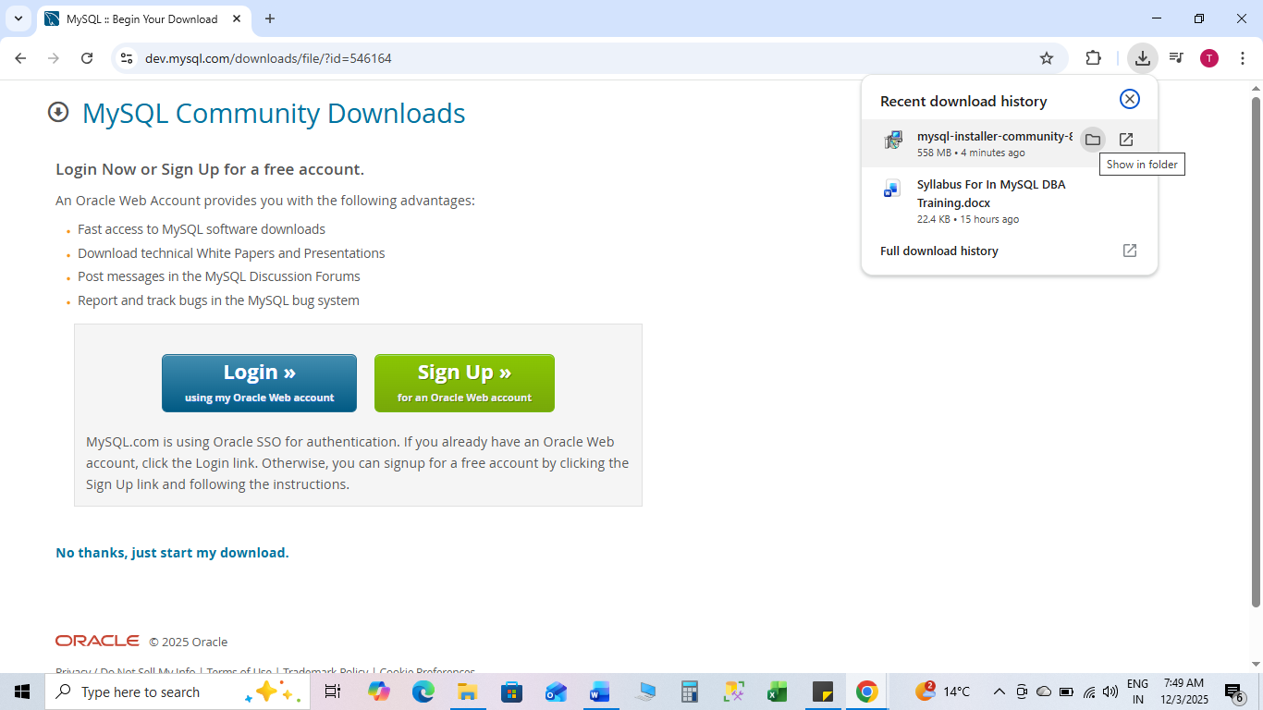

Go to setup file double click on it
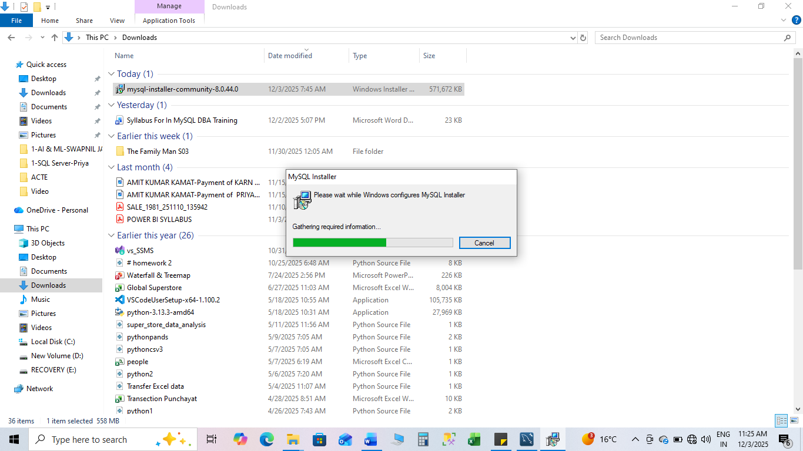

Click on Custom
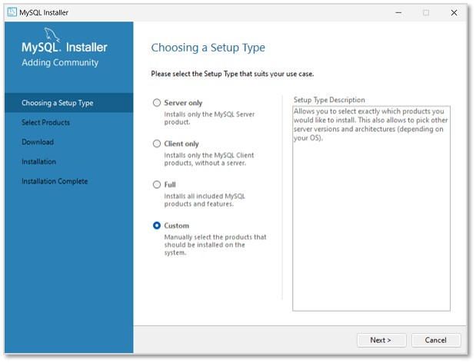
Click next
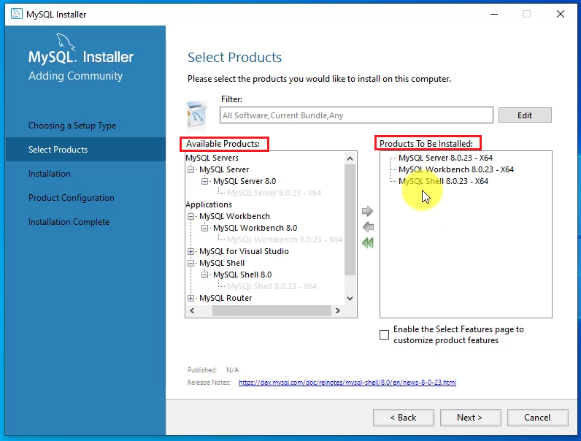
Add MySQL Server 8.0.23-x64
Add MySQL Workbench 8.0.23-x64
Add MySQL Shell 8.0.23-x64
Click next
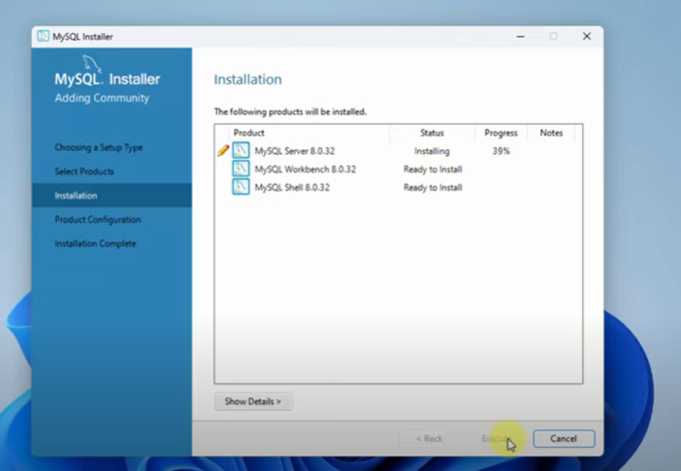
It take time to install all server, workbench, shell
Click next,
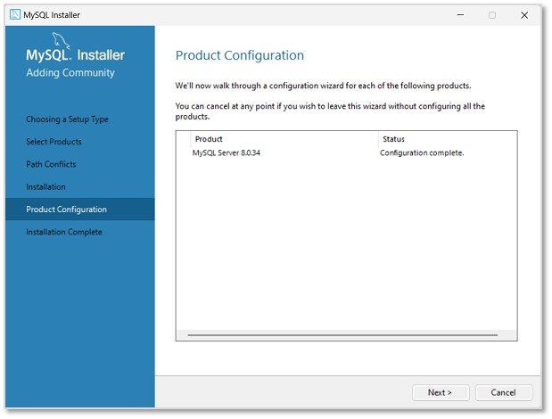
Click next
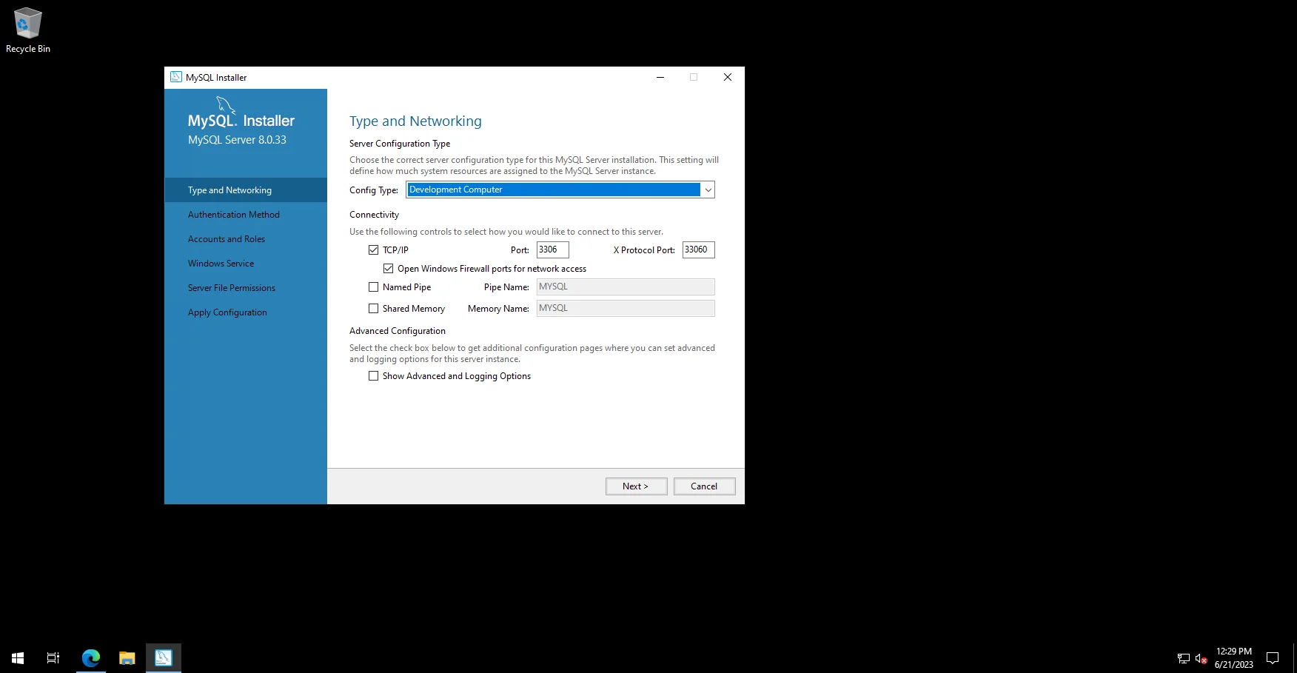
Keep Type and Networking as it is and click next
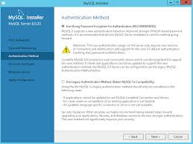
Authentication methods click next
Set password and click next
Keep windows service as it is and click on next
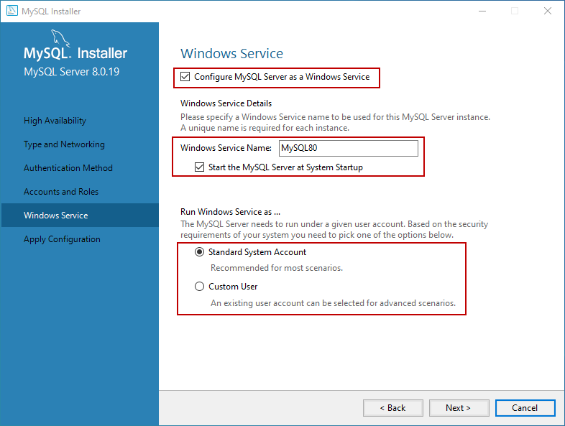

Apply Configuration keep as it is and click Execute
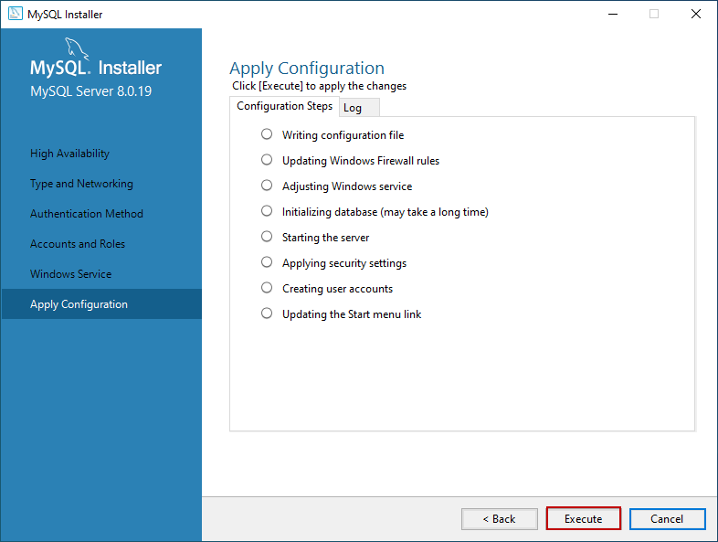
Click finish
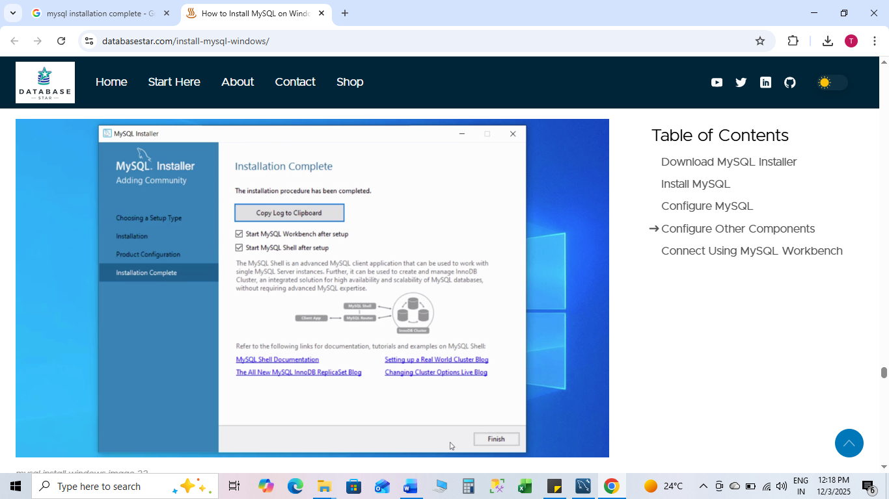
✔ Start MySQL Workbench After setup
✔ Start MySQL Shell After setup
Installation complete click finish

Go to search in computer and type MYSQL and
click on MYSQL WORKBENCH

